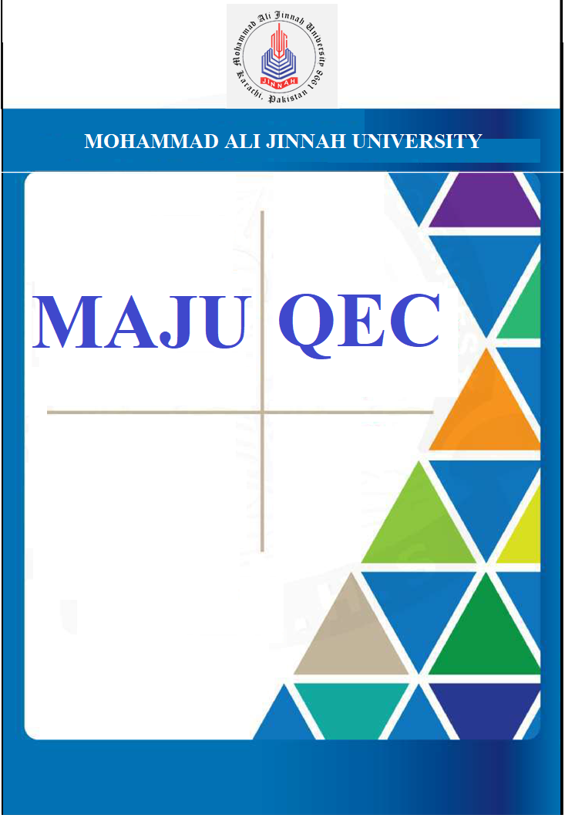
Donation and Fundraising Policy


Policy Document - Donation and Fundraising

1. SECTION 1- PURPOSE

1.1. INTRODUCTION

This Policy establishes a framework for the effective and efficient acceptance and management of philanthropic gifts received by the Mohammad Ali Jinnah University (MAJU), through its fundraising activities.

Philanthropy plays a significant role in fulfilling Mohammad Ali Jinnah University mission and goals. Accordingly, the university welcomes gifts from its graduates, individuals and organizations who are willing to support Mohammad Ali Jinnah University in accomplishing its mission.

1.2. SCOPE

This policy governs the university’s fundraising activities undertaken by or on behalf of Mohammad Ali Jinnah University (MAJU).

This policy applies to all or any people concerned with these activities.

1.4. FUNDRAISING PRINCIPLES

To implement a strategic, uniform and coordinated approach to all or any fundraising activities, the University will:

• Adopt transparent and ethical processes for the acceptance and management of donations and fundraising activities across the entire University.
• Develop operational procedures to accompany each fundraising activity such that a strategic, uniform and coordinated approach to fundraising, gift acceptance and receipting is achieved. This is to ensure that multiple, conflicting, or inappropriate solicitations will be minimized.
• Protect the confidentiality of donors consistent with their wishes and to the extent provided by law. The University will, however, comply with any legal obligation to disclose the names of donors and the nature and value of their donations.
• Adequately identify funds and use them for the purpose for which they were intended

• Manage all fundraising activities via formal communication from the donor i.e agreement, MoU, etc.

In addition to the above, the following principles will also be adhered to:

• The agreement signed by donors will not permit them to influence any decision or behavior of MAJU. Mohammad Ali Jinnah University will safeguard against any undue interference in its activities at all times.

2. SECTION 2 -TYPES OF FUNDS

All funds received by Mohammad Ali Jinnah University (MAJU) fall into two categories, namely, Endowment and Annual Fund.

2.1. ENDOWMENT FUND

An endowment is a permanent gift to the university for its nation-building and university- development endeavors. With an objective of making the University self-reliant, and for offering a sustainable solution to the pressing requirements of a need-based scholarship
program, the endowment module has been segregated at two levels, the General and the

Restricted Endowment.

• 2.1.1. General Endowment Fund consists of a generic pool of unspecified donations. It is a pool of resources that have no restriction upon their spending.
• 2.1.2. Restricted Endowment Fund is a pool of resources that are utilized for a defined purpose.

2.2. ANNUAL FUND/ ZAKAT

Annual Fund is an unrestricted giving, established to meet the interim requirements of the University in its pursuit of being a need-blind institution. It can also be in the form of Zakat, which is spent within a year of its acceptance by Mohammad Ali Jinnah University (MAJU). Zakat Fund is managed under the guidance of a competent Shariah Advisor and is operated on zero operational charges.

3. SECTION 3- GIFTS ACCEPTANCE

Gift acceptance identifies the types of gifts that can be accepted or not accepted by the university. These include:

3.1. ACCEPTABLE GIFTS

The following types of gifts are generally eligible for consideration by the University:

• Cash or cash equivalents (for example, currency, cheques, credit card payments, electronic funds transfers, payroll deductions)
• Gifts-in-kind (for example, artwork, rare books, lab equipment, machinery, and other assets) and real estate consistent with the University’s Gifts-In-Kind Policy (Non- monetary donations) and Bequests (gifts through wills)
• Life insurance

• Charitable trusts

• Publicly-traded securities, on recognized exchanges

3.2. UNACCEPTABLE GIFTS

The university reserves the right to reject a gift offer of any type; cash or equivalent, capacity building, or in kind, under circumstances that the gift does not align with the University’s mission, academic priorities or strategic plan, and accepting such gift can damage the reputation of the institution.

4. SECTION 4- POLICY

4.1. PROSPECTING

Prospect Management is intended to support university fundraising efforts while communicating an integrated message to prospective donors exploring multiple philanthropic interests and opportunities. Prospective donors are tracked and a database is maintained of their status in the gift soliciting cycle. A donor pool of two types is identified under this domain, namely:

• 4.1.1. Ongoing Prospecting: This activity includes tracking, researching, and reporting on possible donors whose portfolio matches the needs of our fundraising campaigns. This dataset is used at the time of developing campaigns and fundraisers to select prospects to be taken in for a gift soliciting cycle and be taken into active portfolios.
• 4.1.2. Campaign Based Prospecting: In the case of a campaign that requires prospect development to find a new set of donor pools, a customized list is created.

4.2. PLEDGE RECORD AND RECOVERY

The pledge record and recovery process, records and manages pledge commitments to ensure effective cultivation and a recovery system. The process defines recovery timelines, ensures the viability of unpaid pledges, and manages the database for pledges due in a future time.

4.3. COMPLIANCE

In order for the donors to maintain a lucrative and long-term relationship with their donating partners, the compliance and reporting function broadly covers the following spectrum:

• Donor and donations management, while sending acknowledgement and confirmation emails to pledge and donation partners.
• Maintain the pledges, donors and donations databases while acting as a liaison for donations related inquiries with external and internal prospects.
• Undertaking statistical analysis with respect to donations and pledges and developing forecasts in relevance.
• Reconciliation of financial funds.

5. SECTION 5- MONITORING AND EVALUATION

This policy will be monitored in line with the strategic fundraising strategy and an update on its effectiveness will be reported to the Mohammad Ali Jinnah University (MAJU) Trust Fund Board on an annual basis. The policy will be fully reviewed every two years or more frequently should legislative requirements change.

6. SECTION 6- DEFINITIONS

• Beneficiary means the recipient of a donation (eg university/faculty/department/project or academic).
• Bequest means a donation of assets or cash by will.

• Cultivation (also donor cultivation) means, for the purpose of this policy, the act of approaching prospective donors via university approved mechanisms, to build relationships with a view to requesting funding or support for the university.
• Donation means a voluntary transfer of money or property to the university by way of benefaction where no material benefit is received by the donor from Mohammad Ali Jinnah University in return.
• Donor means any individual or organization that makes, has made or wishes to make a donation to Mohammad Ali Jinnah University
• Fundraising means all activities undertaken by or on behalf of the university with the aim of seeking or receiving money or property through donation.
• MOU /Agreement means the written record of the terms of the donation as executed by the university and the donor.
• In-kind means a donation made in a manner other than a donation of money.

• Pledge means a documented commitment to make a gift within a specified period of time.

